Ideation Phase
Define the Problem Statements

Date | 31 Jan 2026
Team ID | LTVIP2026TMIDS24920
Project Name | Strategic Product Placement Analysis: UnveilingSales Impact with Tableau Visualization
Marks | 2 Marks

Customer Problem Statement Template:

The Core Challenge

In the competitive retail landscape, the relationship between shelf positioning and consumer purchasing behavior remains opaque. Currently, stakeholders rely on fragmented, static reports that fail to illustrate the direct correlation between where a product is placed and how quickly it sells. This "data silo" effect prevents category managers from identifying high-value zones within the store, leading to missed revenue opportunities and inefficient inventory allocation.

The Solution via Tableau
This project addresses these visibility gaps by engineering a centralized, interactive Tableau Analytical Suite. By consolidating disparate sales metrics into intuitive visual heatmaps and trend dashboards, we aim to:
Quantify Impact: Directly link spatial placement (e.g., eye-level vs. bottom shelf) to SKU velocity.
Enable Agility: Transform raw transactional data into actionable insights, allowing managers to pivot strategies in real-time.
Drive Growth: Empower decision-makers with evidence-based visualizations that remove guesswork from merchandising plans.

Problem Statement1:Regional Sales Manager in a Retail Chain

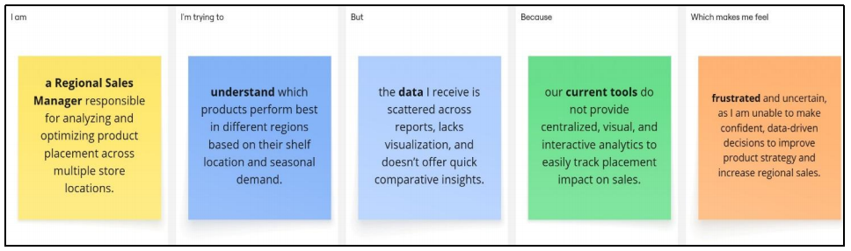

Problem Statement (PS) | I am | I’m trying to | But | Because | Which makes me feel
PS-1: Regional Retail Lead | a Regional Director in charge of maximizing inventory performance across various physical store branches. | determine which items yield the highest ROI based on their aisle positioning and fluctuating seasonal trends. | the current information is fragmented, lacks a visual interface, and fails to provide rapid cross-comparison. | our existing infrastructure does not offer a unified, graphic-heavy platform to monitor how shelf location affects revenue. | discouraged and hesitant, as I cannot make high-stakes, evidence-based choices to refine merchandising or boost regional growth.
PS-2: Consumer Goods Analyst | a Merchandising Analyst supporting sales teams by providing data-driven insights on display effectiveness. | pinpoint how specific in-store layouts drive promotional success and shape the way customers navigate and buy. | Istruggle to get a comprehensive view of product success tied to its physical spot due to rigid, non-interactive reporting. | we are missing a consolidated, live data hub that merges sales patterns with visual placement via advanced tools like Tableau. | burdened and restricted, as I am unable to suggest proactive marketing shifts that would enhance brand exposure and sales.
Problem Statement2: Marketing Analyst at a Fast-Moving Consumer Goods (FMCG) Company

